Student’s Name:

Instructor’s Name:

Course:

Date:

# School Performance

Student performance on math tests is determined by a wide range of factors. These include a student’s social class; educational stage, that is, the grade a student is in; and gender. These factors have varying influences on the students’ performance in math. Being a crucial subject of study at all levels of education, it is essential to leverage them into improving the students’ mathematical skills. In doing so, the school board needs to determine the factors which impact the students’ performance on the math tests in the greatest way in order to prioritize them. The scores in math tests can be modeled as a generalized linear mixed model with these factors as the parameters as follows:

$$math\sim gender + socialClass + grade$$

Each of these factors takes a coefficient which corresponds to its effect on the math score. In order to determine the most important factor, this model was analyzed using Bayesian inference. The prior took into consideration that the number of questions the student gets wrong fits in a Poisson distribution. As such, a Poisson prior was taken for the random effects incorporated in the model. The posterior quantiles of fixed effects parameters were as shown in the table below. Although the results had a limited effectiveness due to the lack of a relatively informed prior, the results held that the grade was the most important factor affecting the performance of students in math tests. In order to confirm this assessment, a histogram of the student’s scores in math tests were plotted in a histogram which highlighted differences across grades.

The results and the histogram suggested that students at more advanced grades had a better grasp of the mathematical concepts under study. As such, the school should develop a more effective method of introducing the learners to mathematical concepts so that they can grasp the ideas even at the lower grades.

# Table: Posterior Quantiles

|  |  |  |  |  |  |  |  |
| --- | --- | --- | --- | --- | --- | --- | --- |
|  |  | mean | sd | 0.025quant | 0.5quant | 0.975quant | mode |
| (Intercept) | 3.32 | 0.02 | 3.27 | 3.32 | 3.37 | 3.32 | 0 |
| genderm | -0.01 | 0.01 | -0.02 | -0.01 | 0.01 | -0.01 | 0 |
| socialClassII | 0.00 | 0.02 | -0.04 | 0.00 | 0.04 | 0.00 | 0 |
| socialClassIIIn | -0.06 | 0.02 | -0.10 | -0.06 | -0.01 | -0.06 | 0 |
| socialClassIIIm | -0.12 | 0.02 | -0.16 | -0.12 | -0.08 | -0.12 | 0 |
| socialClassIV | -0.11 | 0.02 | -0.15 | -0.11 | -0.06 | -0.11 | 0 |
| socialClassV | -0.17 | 0.02 | -0.22 | -0.17 | -0.13 | -0.17 | 0 |
| socialClasslongUnemp |  | -0.15 | 0.03 | -0.20 | -0.15 | -0.10 | 0 |
| socialClasscurrUnemp |  | -0.19 | 0.03 | -0.26 | -0.19 | -0.12 | 0 |
| socialClassabsent | -0.12 | 0.02 | -0.17 | -0.12 | -0.08 | -0.12 | 0 |
| grade1 | 0.00 | 0.01 | -0.02 | 0.00 | 0.02 | 0.00 | 0 |
| grade2 | 0.19 | 0.01 | 0.18 | 0.19 | 0.21 | 0.19 | 0 |

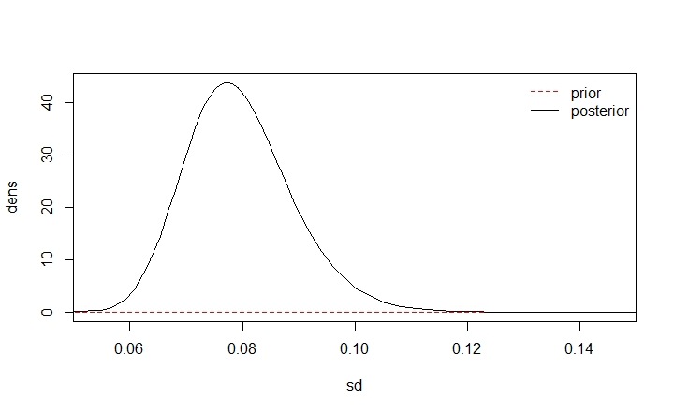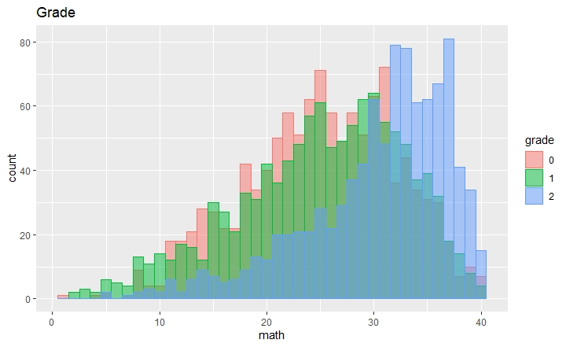

# Table: Regression Result

|  |  |  |  |  |
| --- | --- | --- | --- | --- |
|  | Estimate | Std. Error | z value | Pr(>z) |
| (Intercept) | 27.832 | 1.145 | 24.313 | 0.000 |
| genderm | -0.171 | 0.367 | -0.467 | 0.641 |
| socialClassII | 0.075 | 1.211 | 0.062 | 0.951 |
| socialClassIIIn | -1.733 | 1.273 | -1.361 | 0.173 |
| socialClassIIIm | -3.198 | 1.146 | -2.791 | 0.005 |
| socialClassIV | -2.762 | 1.265 | -2.184 | 0.029 |
| socialClassV | -4.778 | 1.308 | -3.654 | 0.000 |
| socialClasslongUnemp | -3.913 | 1.356 | -2.886 | 0.004 |
| socialClasscurrUnemp | -4.681 | 1.817 | -2.577 | 0.010 |
| socialClassabsent | -3.556 | 1.199 | -2.966 | 0.003 |
| grade1 | 0.022 | 0.160 | 0.139 | 0.889 |
| grade2 | 4.998 | 0.171 | 29.316 | 0.000 |

# Smoking

Smoking impairs the academic capability of students. In order to improve the performance of students in a given area or institution, it is essential to track and mitigate this behavior. To meet this goal, a regression model was created using data from a large number of demographically diverse students. After modelling it into a regression model, Bayesian inference was used to determine whether the differences in numbers of students who smoke were greater when comparing rural-urban areas than across states. The regression model was:

$$y \sim β_{1}sex+β_{2} rural urban+ε$$

In essence, the prevalence of smoking among students was determined by a student’s gender, since boys smoke more than girls; the influence of the student’s environment, which was under evaluation in this study; and other random factors. The student’s environment is an important influence on a student’s attitude towards smoking since it incorporates the societal norms the student is subjected to.

The Bayesian inference assumed a neutral prior with a normal distribution. Based on input from knowledgeable scientists in the field, the study also assumed that the first hypothesis was true. In essence, the process of Bayesian inference assumed that while the worst schools could only go as much as 50% above the best ones, the worst states could have rates as high as 5 to 10 times as much as the bet ones. As such, the inference compared the prevalence of smoking in rural schools to urban ones. The R program for the inference process produced a chart which highlighted a higher prevalence in rural areas than in urban ones. This backed the data obtained from the posterior quantiles. These quantiles are shown in the table below, and thereafter, the chart.

|  |  |  |  |
| --- | --- | --- | --- |
|  | Mean | 0.025quant | 0.975quant |
| (Intercept) | -1.55764530 | -14.8882694 | 11.7403228 |
| SexF | -0.20201241 | 0.2751001 | -0.1290584 |
| ageFac14:RuralUrbanUrban | 0.04053028 | -13.2684388 | 13.3592988 |
| ageFac9:RuralUrbanUrban | 2.83539672 | -10.5085804 | 16.1897097 |
| ageFac10:RuralUrbanUrban | 2.49930235 | -10.9181070 | 15.9287536 |
| ageFac11:RuralUrbanUrban | -2.21530147 | -15.5340745 | 11.1131055 |
| ageFac12:RuralUrbanUrban | -0.92438196 | -14.2342105 | 12.3952359 |
| ageFac13:RuralUrbanUrban | -0.57487018 | -13.8840761 | 12.7441335 |
| ageFac15:RuralUrbanUrban | 0.59105884 | -12.7177673 | 13.9096869 |
| ageFac16:RuralUrbanUrban | 0.82389942 | -12.4848825 | 14.1424835 |
| ageFac17:RuralUrbanUrban | 1.16926139 | -12.1394700 | 14.4877958 |
| ageFac18:RuralUrbanUrban | 1.14241632 | -12.1666466 | 14.4612805 |
| ageFac19:RuralUrbanUrban | 1.93199832 | -11.3843557 | 15.2581263 |
| ageFac14:RuralUrbanRural | 0.26098021 | -13.0480073 | 13.5797593 |
| ageFac9:RuralUrbanRural | 25.25693900 | 7.0909395 | 54.0059524 |
| ageFac10:RuralUrbanRural | -22.67738687 | -55.1292205 | -2.5535838 |
| ageFac11:RuralUrbanRural | -1.27691681 | -14.5913317 | 12.0472275 |
| ageFac12:RuralUrbanRural | -0.61704557 | -13.9267641 | 12.7024580 |
| ageFac13:RuralUrbanRural | -0.06554936 | -13.3746853 | 13.2533768 |
| ageFac15:RuralUrbanRural | 0.75874864 | -12.5501327 | 14.0774238 |
| ageFac16:RuralUrbanRural | 1.11342833 | -12.1953547 | 14.4320073 |
| ageFac17:RuralUrbanRural | 1.31029311 | -11.9984990 | 14.6288791 |
| ageFac18:RuralUrbanRural | 1.46433105 | -11.8447647 | 14.7832197 |
| ageFac19:RuralUrbanRural | 1.45295148 | -11.8616748 | 14.7773407 |
| SD for state | 0.42032683 | 0.3129369 | 0.5634823 |

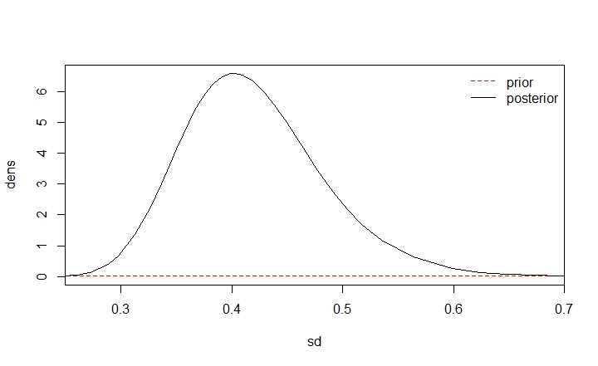

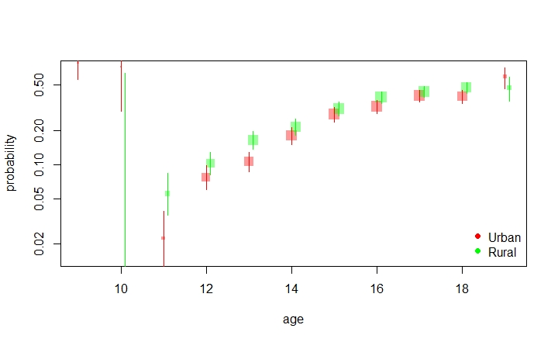

# References

Question 1

library(INLAutils)

library(INLA)

library(ggplot2)

library(tidyverse)

#load data

sUrl = "http://www.bristol.ac.uk/cmm/media/migrated/jsp.zip"

dir.create(file.path("..", "data"), showWarnings = FALSE)

(Pmisc::downloadIfOld(sUrl, file.path("..", "data")))

#create dataset from the info

school = read.fwf("../data/JSP.DAT", widths = c(2, 1, 1, 1, 2, 4, 2, 2, 1),

col.names = c("school", "class", "gender", "socialClass",

"ravensTest", "student", "english", "math", "year"))

#variables

school$socialClass = factor(school$socialClass,

labels = c("I", "II", "IIIn", "IIIm", "IV", "V",

"longUnemp", "currUnemp", "absent"))

school$gender = factor(school$gender, labels = c("f", "m"))

school$classUnique = paste(school$school, school$class)

school$studentUnique = paste(school$school, school$class,school$student)

school$grade = factor(school$year)

#generalized linear model

schoolLme = glmmTMB::glmmTMB(math ~ gender + socialClass + grade + (1 | school) +

(1 | classUnique) + (1 | studentUnique), data = school)

summary(schoolLme)

knitr::kable(summary(schoolLme)$coef,digits = 3,caption = 'Regression Result')

#histogram

hist(1 - school$math, breaks = 100)

#INLA

mathscore = INLA::inla(math ~ gender + socialClass + grade+ f(

school, model='iid',

prior='pc.prec',

param = c(30, 0.5)),

data = school, family='poisson')

summary(mathscore)

knitr::kable(mathscore$summary.fixed, digits = 2, caption = "Posterior Quantiles")

#Plots of the original data

genderplot <- ggplot(school, aes(x= math, fill=gender, color=gender)) +

geom_histogram(position="identity", binwidth=1, alpha=0.5) + labs(title = "Gender")

soclassplot <- ggplot(school, aes(x= math, fill=socialClass, color=socialClass)) +

geom_histogram(position="identity", binwidth=1, alpha=0.5) + labs(title = "Socialclass")

gradeplot <- ggplot(school, aes(x= math, fill=grade, color=grade)) +

geom_histogram(position="identity", binwidth=1, alpha=0.5) + labs(title = "Grade")

genderplot

soclassplot

gradeplot

#PLot of prior and posterior

sdRes = Pmisc::priorPostSd(mathscore)

do.call(matplot, sdRes$matplot)

do.call(legend, sdRes$legend)

Question 2

library("INLA")

library("INLAutils")

#load data

dataDir = '../data'

smokeFile = file.path(dataDir, 'smoke2014.RData')

if(!file.exists(smokeFile)){

download.file(

'http://pbrown.ca/teaching/appliedstats/data/smoke2014.RData',

smokeFile)

}

load(smokeFile)

smoke[1:3,c('Age','ever_cigarettes','Sex','Race',

'state','school', 'RuralUrban')]

#define variables

forInla = smoke[,c('Age','ever_cigarettes','Sex','Race',

'state','school', 'RuralUrban')]

forInla = na.omit(forInla)

forInla$y = as.numeric(forInla$ever_cigarettes)

forInla$ageFac = relevel(factor(forInla$Age), '14')

#INLA

toPredict = expand.grid(

ageFac = levels(forInla$ageFac),

RuralUrban = levels(forInla$RuralUrban),

Sex = levels(forInla$Sex)

)

forLincombs = do.call(inla.make.lincombs,

as.data.frame(model.matrix( ~ ageFac:RuralUrban + Sex,

data=toPredict)))

fitS2 = inla(y ~ Sex + ageFac:RuralUrban +

f(state, model='iid', hyper=list(

prec=list(prior='pc.prec', param=c(99, 0.05)))

),

data=forInla, family='binomial',

lincomb = forLincombs, control.compute=list(return.marginals=TRUE))

knitr::kable(fitS2$summary.fixed, digits = 2, caption = "Posterior Quantiles")

#plot prior and posterior

sdRes = Pmisc::priorPostSd(fitS2)

do.call(matplot, sdRes$matplot)

do.call(legend, sdRes$legend)

dim(toPredict)

dim(fitS2$summary.lincomb.derived)

toPredict[1:2,]

fitS2$summary.lincomb.derived[1:2,]

rbind(

fitS2$summary.fixed[, c('mean','0.025quant','0.975quant')],

Pmisc::priorPostSd(fitS2)$summary[, c('mean','0.025quant','0.975quant')]

)

theCoef = exp(fitS2$summary.lincomb.derived[,

c('0.5quant','0.025quant','0.975quant')])

theCoef = theCoef/(1+theCoef)

theSd = fitS2$summary.lincomb.derived[,'sd']

toPredict$Age = as.numeric(as.character(toPredict$ageFac))

isMale = toPredict$Sex == 'M'

shiftRural = 0.1*(toPredict$RuralUrban == 'Rural')

theCex = min(theSd)/theSd

plot(toPredict[isMale,'Age'] + shiftRural[isMale],

theCoef[isMale,'0.5quant'],

xlab='age', ylab='probability', ylim = c(0.015, 0.7),

pch = 15, log='y',

cex = 2*theCex,

col = mapmisc::col2html(

c(Urban = 'red', Rural = 'green')[as.character(toPredict[isMale,'RuralUrban'])],

0.4)

)

segments(toPredict[isMale,'Age']+ shiftRural[isMale],

theCoef[isMale,'0.025quant'],

y1=theCoef[isMale,'0.975quant'],

col = c(Urban = 'red', Rural = 'green')[as.character(toPredict[isMale,'RuralUrban'])])

legend('bottomright', pch=16, col=c('red','green'), legend = c('Urban','Rural'),

bty='n')